**Content Based Recommendations**

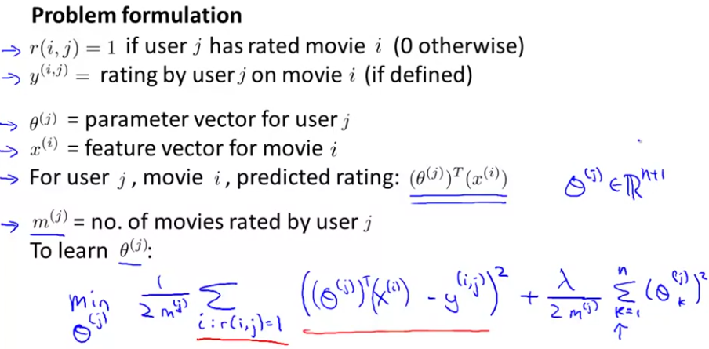

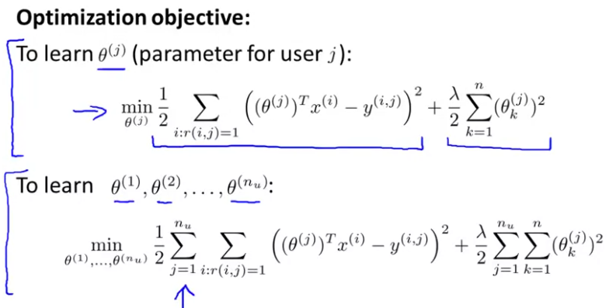

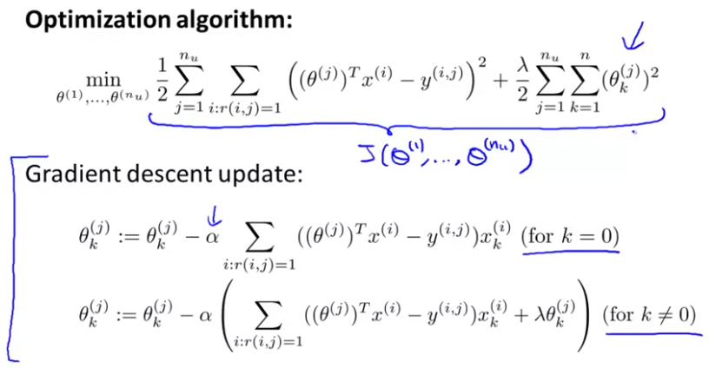

**Collaborative filtering**

In this case, we start by knowing the values of the parameters θj and then we obtain the features X.

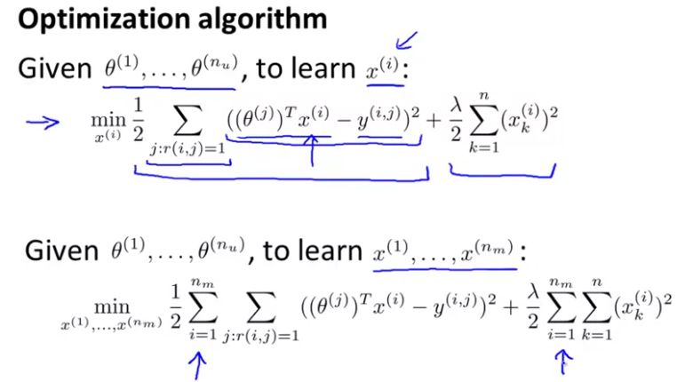

With the two algorithms we have talked about before, we can start an iterative process that allows us to automatically define our features and our theta parameters. This way, we obtain a new optimization algorithm that allows us to minimize both X and θ at the same time.

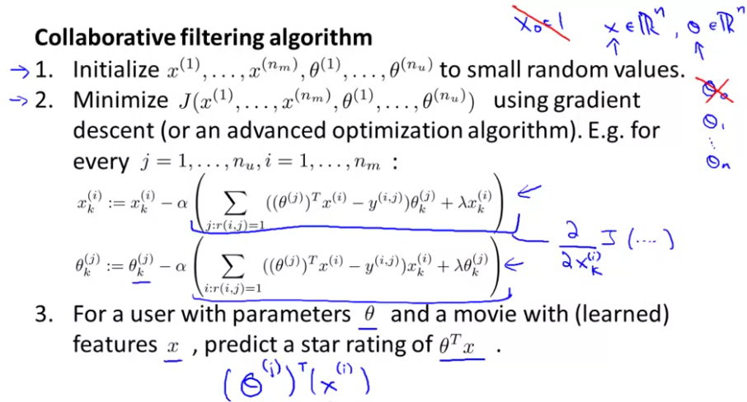

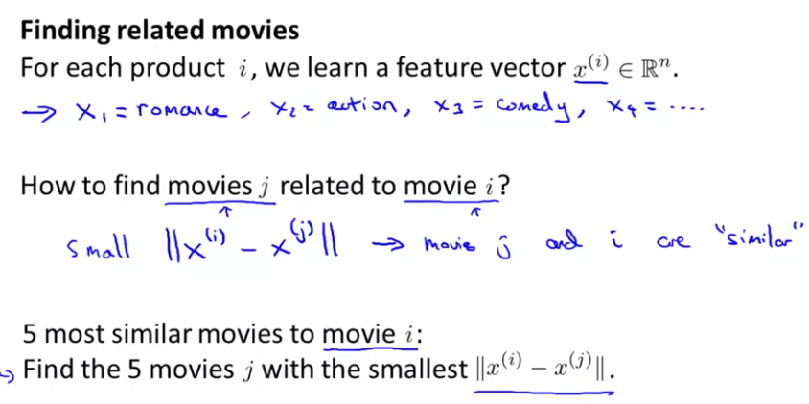

**Mean Normalization**

We compute the average rating for each example, and then we substract it. For each new user, we will start initializating their ratings at he value of the mean:

